British Airways CSAT Analysis
Project Overview
Customer satisfaction is very important in the airline industry because it helps companies understand passenger experience and improve their services. This project focuses on analyzing customer satisfaction (CSAT) data of British Airways using Power BI. The dataset contains passenger reviews, ratings, travel details, and recommendation information collected from different countries.
The main aim of this project is to study customer feedback and identify how passengers rate different services such as cabin staff service, food and beverages, seat comfort, entertainment, and ground service. An interactive dashboard was created in Power BI to visualize key metrics, trends over time, and comparisons across countries. This dashboard helps users easily explore the data and gain meaningful insights that can support better business decisions.
Business Problem Statement
The airline industry is highly competitive, and customer satisfaction plays a key role in retaining passengers. British Airways management wants to analyze CSAT data to understand customer experience, identify strengths and weaknesses, and make data-driven decisions to improve service quality across different regions, aircraft, and passenger categories.
Objectives of the Project
The main objectives of this project are:
- To analyze overall customer satisfaction ratings of British Airways
- To compare customer ratings across different countries
- To understand passenger feedback on various services such as food, seat comfort, and cabin staff
- To identify trends in customer ratings over time
- To present insights using an interactive Power BI dashboard for easy analysis
Dataset Description
This project uses customer satisfaction data collected from British Airways passengers. The data is provided in CSV format and contains information about passenger reviews, ratings, travel details, and recommendation status.
Two datasets are used in this project:
- ba_reviews.csv – This file contains passenger reviews, ratings for different services, travel dates, seat type, aircraft type, traveler type, country, and recommendation details.
- Countries.csv – This file contains country-related information used to support country-level analysis.
Both datasets were connected in Power BI using the country field to enable accurate filtering and comparison across different countries.
Data Cleaning and Preparation
Before creating the dashboard, the data was cleaned and prepared to ensure accurate analysis. The following steps were performed in Power BI:
- Converted columns to correct data types such as date, number, and text
- Removed unnecessary rows and handled invalid values
- Managed missing values by keeping them as blank or unknown where appropriate
- Ensured rating columns contained only numeric values
- Checked and maintained proper relationships between datasets
These data cleaning steps helped improve data quality and ensured that the dashboard visuals displayed correct and reliable insights.
Tools and Technologies Used
The following tools and technologies were used to complete this project:
- Power BI Desktop – Used for data cleaning, data modeling, and dashboard creation
- CSV Files – Used as the source of customer satisfaction data
- DAX (Data Analysis Expressions) – Used to create measures such as average ratings and number of reviews
- Power Query – Used for data cleaning and transformation

Dashboard Visual Analysis
The Power BI dashboard contains several key visualizations that help analyze customer satisfaction effectively:
- KPI Cards display average ratings for overall experience and different service categories
- Bar Charts show the comparison of average ratings and number of reviews across countries
- Line Chart presents the trend of average customer ratings over time
- Donut Chart highlights the recommendation status of passengers (Yes/No)
These visualizations make it easy for users to understand patterns, compare performance, and identify important insights at a glance.

Screenshot: Dashboard Output
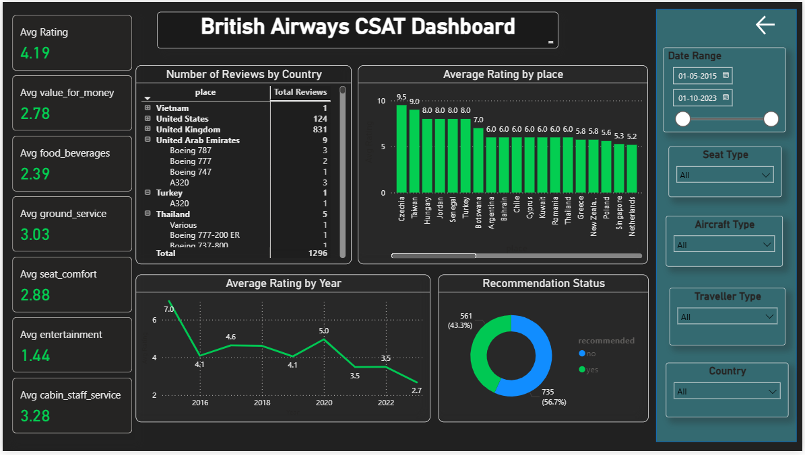
Key Insights from the Dashboard

1️⃣ More Reviews Does Not Mean Better Experience
United Kingdom
- Reviews: 831 (highest)
- Rating: around 6.0
👉 The UK has many reviews, but the rating is not very high.
Insight:
More passengers give more feedback, but satisfaction can still be average.

2️⃣ Small Countries Can Have High Ratings
Czechia
- Rating: 9.5 (highest)
- Reviews: Very few
Taiwan
- Rating: 9.0
- Reviews: Low
Insight:
Some countries show very high ratings, but only a few people reviewed them.
📌 We should be careful because fewer reviews may not show the full picture.

3️⃣ Customer Satisfaction Is Going Down Over Time
Rating by Year
- 2015: 7.0
- 2016: 4.1
- 2020: 5.0
- 2023: 2.7 (lowest)
Insight:
Customer satisfaction has decreased in recent years.
📌 This shows service quality needs improvement.

4️⃣ Staff Service Is Good, Entertainment Is Poor
Best Service
- Cabin Staff Service: 3.28
Worst Service
- Entertainment: 1.44
- Food & Beverages: 2.39
Insight:
Passengers like the staff, but they are unhappy with entertainment and food.

5️⃣ Not All Customers Recommend the Airline
- Recommend: 56.7%
- Do Not Recommend: 43.3%
Insight:
More than half of the passengers recommend British Airways, but many are still unhappy.
📌 Improving weak areas can increase recommendations.

⭐ Overall Summary (Very Simple)
- Staff service is good
- Entertainment service is poor
- Ratings are falling over time
- UK has the most reviews
- Customer opinions are mixed

conclusion
British Airways has average customer satisfaction and needs to improve onboard services to increase customer happiness.

Screenshot: Input Dataset

